**TASK 2 (6*2=12 marks)**

**Apurba Koirala**

**22BCE3799**

**Program 1**

Write a program to add 10 bytes of data and store the result in registers R2 and R3. The bytes are stored in the ROM space starting at 200H. The data would look as follows:

MYDATA: DB 92, 34, 84, 129, ... ;

Pick your own data. Notice that you must first bring the data from ROM space into the CPU's RAM, and then add them together. Use a simulator to single-step the program and examine the data.

Code and Output

ORG 0

MOV DPTR, #200H

MOV R0, #10

LOOP:

CLR A

MOVC A, @A + DPTR

MOV A, R2

JNC NEXT

INC R3

NEXT:

INC DPTR

MOV R2, A

DJNZ R0, LOOP

HERE:

SJMP HERE

ORG 200H

DB 32H, 43H, 23H, 84H, 31H, 97H, 91H, 33H, 49H, 07H

END

**Program 2**

Write a program to add 10 bytes of BCD data and store the result in R2 and R3. The bytes are stored in ROM space starting at 300H. The data would look as follows:

MYDATA: DB 92H, 34H, 84H, 29H, ... ; pick your own data.

Notice that you must first bring the data from ROM space into the CPU's RAM, and then add them together. Use a simulator to single-step the program and examine the data.

Code and Flowchart

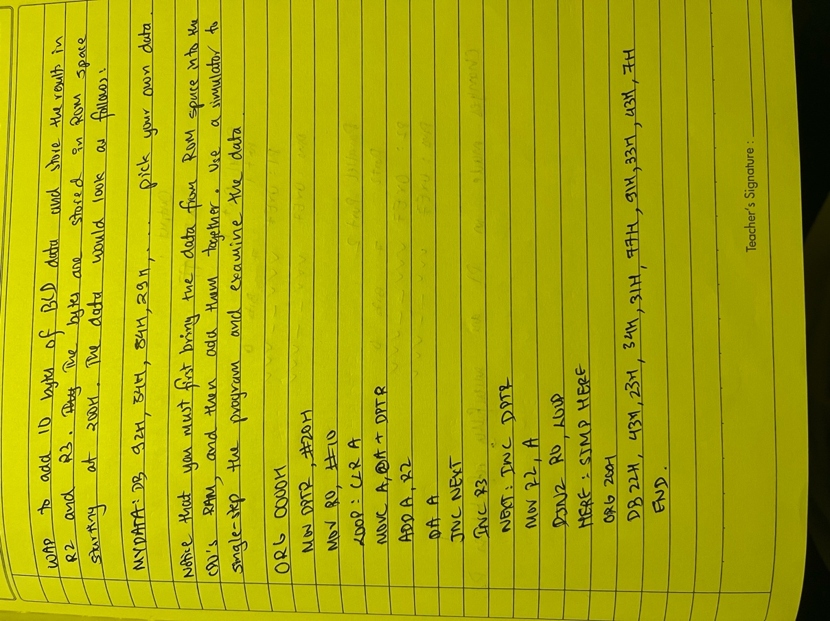

Snapshot of Code and Output:

ORG 0000H

MOV DPTR, #300H

MOV R0, #10

LOOP:

CLR A

MOVC A, @A + DPTR

ADD A, R2

DA A

JNC NEXT

INC R3

NEXT:

INC DPTR

MOV R2, A

DJNZ R0, LOOP

HERE:

SJMP HERE

ORG 300H

DB 22H, 43H, 23H, 34H, 31H, 77H, 91H, 33H, 43H, 07H

END